**Project Design Phase-II**

**Data Flow Diagram & User Stories**

|  |  |
| --- | --- |
| Date | 26 June 2025 |
| Team ID | LTVIP2025TMID48508 |
| Project Name | Heritage Treasures: An In-Depth Analysis of UNESCO World Heritage Sites in Tableau |
| Maximum Marks | 4 Marks |

**Data Flow Diagrams:**

A Data Flow Diagram (DFD) is a traditional visual representation of the information flows within a system. A neat and clear DFD can depict the right amount of the system requirement graphically. It shows how data enters and leaves the system, what changes the information, and where data is stored.



**Example:** [**(Simplified)**](https://developer.ibm.com/patterns/visualize-unstructured-text/)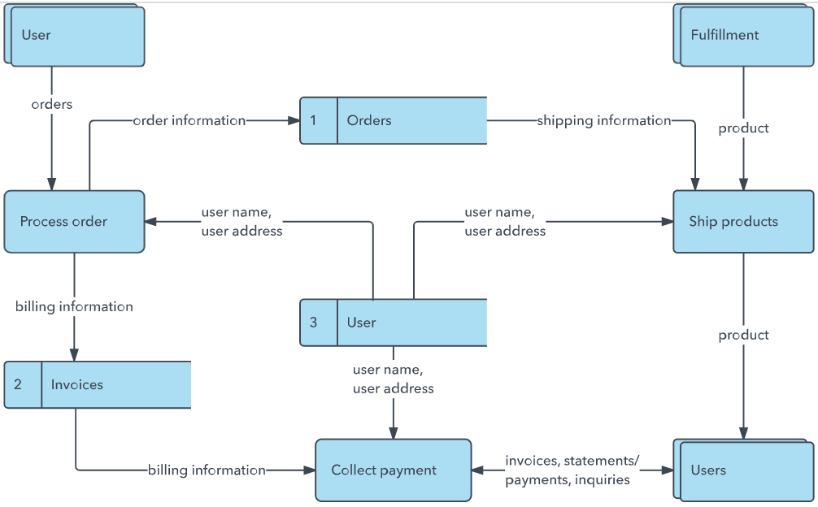

**User Stories**

|  |  |  |  |  |  |  |  |  |  |  |  |  |  |  |  |
| --- | --- | --- | --- | --- | --- | --- | --- | --- | --- | --- | --- | --- | --- | --- | --- |
| **Site Name** | **Country** | **Region** | **Category** | **Year Inscribed** | **Criteria** | **Longitude** | **Latitude** | **Description** | **Threat Level** | **Visitor Count (Estimate)** | **Image URL** |  |  |  |  |
| Taj Mahal | India | Asia | Cultural | 1983 | (i)(ii)(iii) | 78.0421 | 27.1751 | A white marble mausoleum in Agra, India, built by Mughal emperor Shah Jahan. | Not Endangered | 8000000 | <https://example.com/tajmahal.jpg> | | | |  |
| Machu Picchu | Peru | South America | Mixed | 1983 | (i)(iii)(vii)(ix) | -72.545 | -13.1631 | A 15th-century Inca citadel located in the Eastern Cordillera of southern Peru. | Not Endangered | 1500000 | <https://example.com/machupicchu.jpg> | | | |  |
| Stonehenge | United Kingdom | Europe | Cultural | 1986 | (i)(ii)(iii) | -1.8262 | 51.1789 | A prehistoric monument consisting of a ring of standing stones. | Not Endangered | 1200000 | <https://example.com/stonehenge.jpg> | | | |  |
| Great Barrier Reef | Australia | Oceania | Natural | 1981 | (vii)(ix)(x) | 147.7 | -18.2871 | World’s largest coral reef system composed of over 2,900 individual reefs. | Endangered | 2000000 | <https://example.com/greatbarrierreef.jpg> | | | | |
| Acropolis of Athens | Greece | Europe | Cultural | 1987 | (i)(ii)(iii)(iv)(vi) | 23.7265 | 37.9715 | An ancient citadel located on a rocky outcrop above the city of Athens. | Not Endangered | 7000000 | <https://example.com/acropolis.jpg> | | | |  |